# How Gardening Can Make You A Better Writer

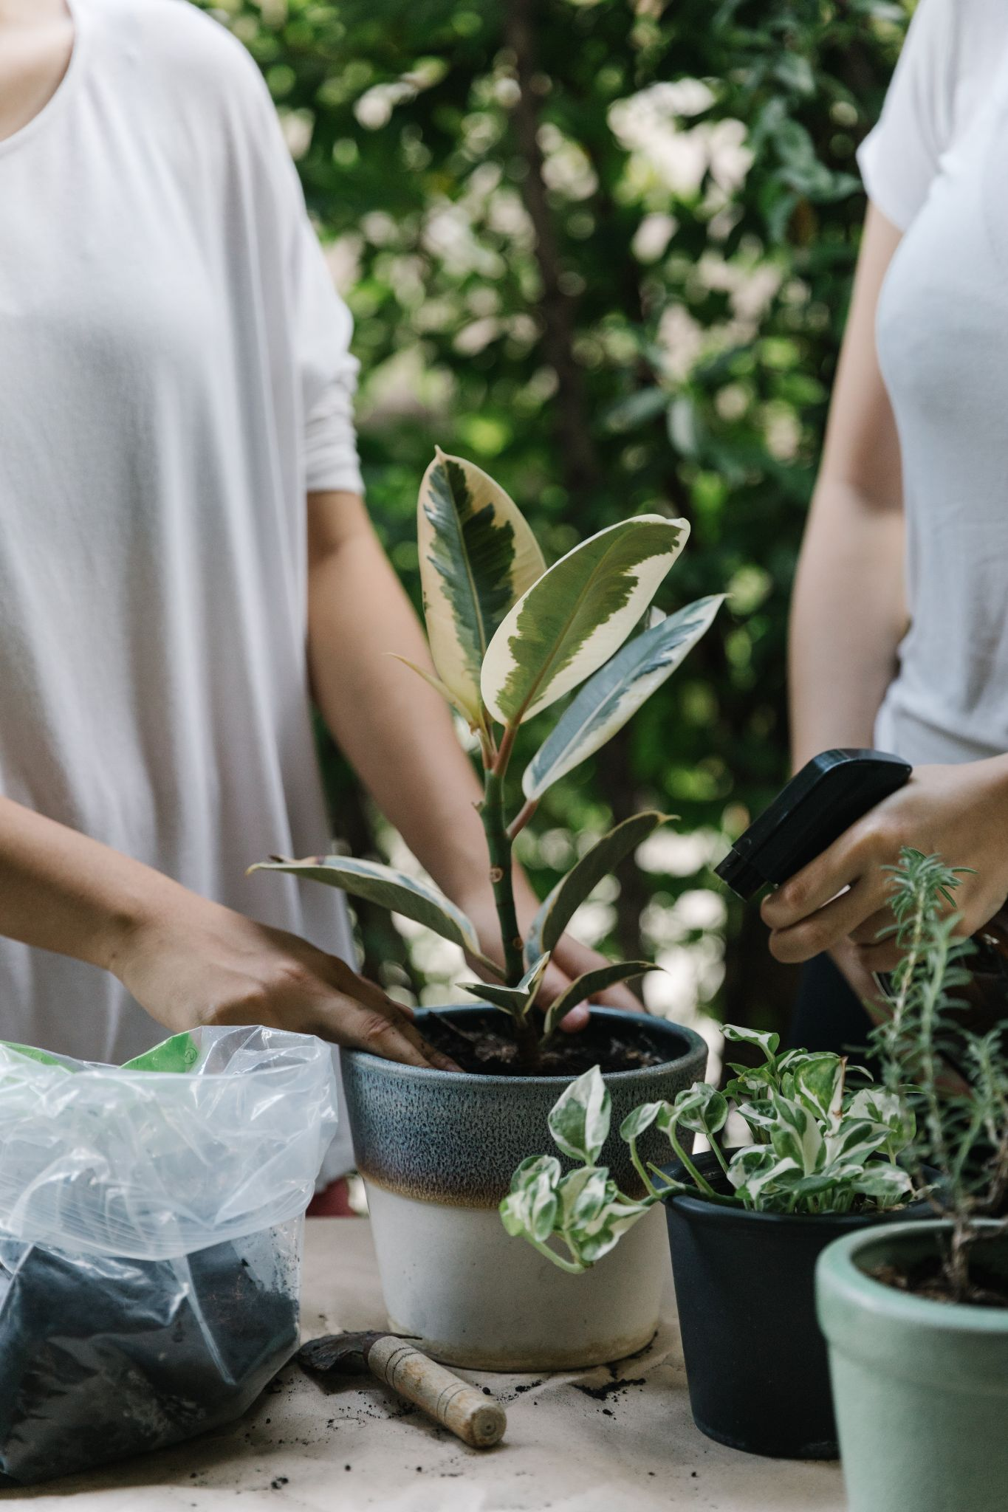

<https://images.pexels.com/photos/4132362/pexels-photo-4132362.jpeg>

Can a dream to become a writer come true? How to achieve the goal if everything distracts you from practicing? Do not let hesitations stop you! Many people went through the same difficulties. Check out all the activities that can bring you inspiration and energy. We are here to suggest gardening as the way of writing improvement.

## Why gardening?

Teachers working by Montessori's techniques describe gardening as affecting the development of kids. That is Montessori's idea to be in contact with nature. Such interaction develops perception and combines information from different senses. It brings us all the diversity of textures, shapes, colors, smells, and tastes. Although that is a method for kids, it is helpful to any grown-up person. Write down your thoughts. Tell about your first experience in any business. If you love gardening, research more and create essays about that. The result may be more than you thought it would be. Check this out! Here a gardener gives [tips](https://laidbackgardener.blog/2021/12/29/how-to-write-a-gardening-blog-and-make-it-visible-on-google/) on how to handle the blog about plants.

### # It improves perception

Cognitive development stands for the way the human mind processes any information. Plant a seed and look at how it grows and turns into a flower! That is the observation of cause-and-effect relationships and lessons to be patient. Moreover, a person becomes attentive to details. Diverse plants need different amounts of water and fertilizers. Taking care of little sprouts helps get a scientific and philosophical worldview. If you can look after something else, you can do it on your behalf. Thus, keep on practicing your writing skills!

### # It develops manual dexterity

A gardener deals with planting seeds and cultivating the ground. He removes dried leaves and performs much more tasks. Thus, he makes exercises his body and hands. The small muscles and fingers move better. As a result, he improves coordination and blood circulation. Do that, you will write much more!

## Create own garden

That is simple to arrange. Paying attention to the dimension of your terrace and its climate, choose good plants. Pick up edible lettuce, herbs, and strawberries. You may also select colorful flowers, for example, violets, chrysanthemums, hibiscus. Your choice may have a remarkable effect on your psychological condition and health. Buy tools to deal with plants and ground.

## How to begin writing?

As well as an athlete builds his muscle, a writer-to-be improves his writing skills. The main point is to do it day by day. Better to have a short practice of about fifteen minutes. You may write anything, a post to Facebook or some observations notes. Thus, you form a good habit and grow your level of self-confidence!

### # Small goals strategy

Avoid setting ambitious goals for daily compliance. Better plan fewer things but achieve them. When one fails with a hundred tasks, one may never return to trying. Encourage yourself! Try to end a few paragraphs instead of two thousand words and do the job. If you do so within several weeks, you will get the result. You will have some schedule, new skills, and experience of accomplished things. Learn that your goal is achievable. Thus, if your days are busy and full of stress, that does not matter. Besides, you can send your samples to [Writing Judge](https://www.writingjudge.com/dissertation-writing-services-reviews) for writing services reviews and get your score. Keep on improving!

### # Set priorities

Anton Chekhov with his family lived in the village for almost a decade. They bought a manor, built a few outbuildings, and laid out a garden. The family worked hard when the sun rose and received guests with cordiality. Chekhov worked there with the household and managed to write 42 volumes!

Many routine things must get our attention. It is so because one must go to work, take care of family, cook a meal, and clean house. You are not alone in that! Many authors had a hard time but got their way. For example, Kurt Vonnegut, an American writer, woke up at half-past six daily to write and then went to work. His other colleague, Toni Morrison, worked on papers at 4 am before her kids woke up. They wrote daily. Add that activity to your schedule and a to-do list as a duty. Having a goal, find a little time to write.

### # Hear your feelings

There is not such a notion as the right time to learn and practice writing. Turn that into your hobby and find a possibility to do it every day.

You may choose the better time during the day. Biorhythms of people are different. Some, like Stephen King, prefer working on mornings after waking up. There are legends about his two thousand words daily. Other people write when they get a chance to do that. Ray Bradbury achieves the number of words daily despite the absence of a strict schedule.

### # Do not edit too early

Stop being a writing perfectionist! Do not fall into vain editing of your texts when you collect ideas. First, invent original thoughts and compel captivating stories. Then, bring the writing to perfection by editing it. While doing these things, the brain has to perform two tasks that contradict each other. One brain part is in charge of being creative. Another handles with getting rid of unnecessary text. If you hesitate on some points, use [Best Writers Online](https://bestwritersonline.com/) services. With an individual approach, their custom writing reviews will be your helping hand.

### # Train brains!

Improve associative thinking. Select any word from the dictionary. Start writing down every association with it. It may be a story about something, a practice article, or a funny memory. To avoid distractions, lock all notifications on the screen. Better use paper and a pen. Find a quiet place to work.

## Bonus drop of inspiration

Borys Pasternak is a poet and Laureate of the Nobel Prize in 1958. He was a city resident. Yet, his parents grew him to know what gardening was and how to take care of plants. When Pasternak obtained his house with land in the village area, he started to equip the farm there.

Borys wrote in the early morning and went to work. When returning, he visited the garden to handle some tasks there. Cutting dry branches from apple trees and fertilizing the land made him peaceful. He admired that outdoor activity very much. The poet's contemporaries called him "a brilliant summer gardener."

Writers experience a lack of ideas because they don't have a hobby to retrieve. Gardening is a unique activity that makes all areas of life better. It trains a soul and a body. Regular exercises and deals in the garden make thoughts and ideas come to your mind faster.

References:

<https://www.center-sozvezdie.ru/journal/sadovodstvo-v-montessori-srede-chem-polezna-rabota-s-rasteniyami-dlya-doshkolnikov.html>

<https://blog.mann-ivanov-ferber.ru/2019/05/30/kachajte-tvorcheskuyu-myshcu-i-eshhe-7-sovetov-dlya-tex-kto-mechtaet-napisat-knigu/>

<https://www.culture.ru/materials/254562/dachnaya-kultura-fermer-tolstoi-sadovod-chekhov-i-ogorodnik-pasternak>